

<Project Name> Project
Supplementary Specification

Version <1.0>

Revision History
Date | Version | Description | Author
<12/03/2012> | 1.0 | Supplementary Specification Document Initial Release. | Weijian Jiang

Table of Contents
1. Introduction 5
1.1 Purpose 5
1.2 Scope 5
1.3 Definitions, Acronyms, and Abbreviations 5
1.4 References 6
1.5 Overview 6
2. Functionality 6
2.1 Logon Capabilities 6
2.2 Mobile Devices 6
2.3 Regulation 6
2.4 Tracking 6
3. Usability 6
4. Reliability 6
4.1 Avaliability 6
4.2 Mean Time Between Failures (MTBF)
4.3 Mean Time to Repair(MTTR) 7
4.4 Accuracy 7
4.5 Maximum Bugs or Defect Rate 7
4.6 Access Reliability 7
5. Performance 7
5.1 Response Time 7
5.2 Throughput 7
5.3 Capacity 7
5.4 Resource Utilization 7
6. Supportability 7
6.1 Internet Protocols 7
6.2 Maintenance 7
6.3 Standards 7
7. Design Constraints 7
7.1 Software Language Used 7
7.2 Development Tools 7
8. Online User Documentation and Help System Requirements 7
9. Purchased Components 8
10. Interfaces 8
10.1 User Interfaces 8
10.2 Hardware Interfaces 8
10.3 Software Interfaces 8
10.4 Communications Interfaces 8
11. Licensing Requirements 9
12. Legal, Copyright, and Other Notices 9
13. Applicable Standards 9

Supplementary Specification

Introduction
The University of South Alabama's campus transportation system, JagTran, was created to provide easy, safe and efficient transportation for USA students, employees and visitors. JagTran vehicles run continuously throughout the day, starting at 7:10 a.m. on the main campus. No tickets, money or reservations are needed.

We have decided to investigate the use of JagTrack System. This system would be used by members who may be students or professors of the University of South Alabama to transport people from Point A to Point B. The purpose of this document is to analyze and elaborate on the high-level needs and features of the JagTrack System. It focuses on the capabilities and facilities provided by transportation. The details of what all are the needs of JagTrack System and if it fulfills these needs are detailed in the use-case and supplementary specifications.

Purpose
The purpose of Supplementary Specification document is to describe the external behavior of the JagTrack System. Requirements Specification defines and describes the operations, interfaces, reliability, supportability, performance, and quality assurance requirements of the JagTrack System. The document also describes the nonfunctional requirements such as the user interfaces. It also describes the design constraints that are to be considered when the system is to be designed, and other factors necessary to provide a complete and comprehensive description of the requirements for the software. The Supplementary Specification captures the complete software requirements for the system, or a portion of the system.

Scope
The JagTrack System that is to be developed provides the members of the passages and employees of the JagTran with tracking information, line information, buses information , stops information and many other facilities. The JagTrack System is supposed to have the following features.

- The JagTrack system will be available at all times when JagTran operates.
- The system will provide the ability for users to log on.
- The system lets administrators check users’ permissions have and regulate access.
- The system allows admnistrators to operate a management system and tracking journal.

The features that are described in this document are used in the future phases of the development cycle. The features described here meet the needs of all the users. The success criteria for the system is based in the level up to which the features described in this document are implemented in the system.

Definitions, Acronyms, and Abbreviations
- USA – University of South Alabama.
- SS – Supplementary Specification
- Provided wherever necessary in the document.
- PIN – Personal Identification Number

References
The SS document uses the following documents as references:
The JagTrack System: To provide the user interface system being developed and the system currently in use to update the line and route information, etc.

Overview
The SS will provide a detailed description of the JagTrack System. This document will provide the outline of the requirements, overview of the characteristics and constraints of the system.
The section will provide the general factors that affect the System and its requirements. The items such as system perspective, system function, user characteristics, constraints, and requirements subsets are described in this section. Besides, the section also contains all the requirements mentioned in detail sufficient enough to enable designers to design the system to satisfy the requirements and testers to test if the system satisfies those requirements.

Functionality
The functions of the system include the system providing different type of services based on the type of user.

Logon Capabilities
The system shall allow the users to have logon capabilities.

Mobile Devices
The JagTrack System should be supported on Android devices with location awareness features.

Regulation
The system can deal with emergency efficiently in case of any problems.

Tracking
The system should be able to track people on the bus.

Usability

3.1 Android Compliance
The user interface shall be Android compliant.
3.2 Design for Ease-of-Use
The user interface of the JagTrack System shall be designed for ease-of-use and shall be appropriate for a smartphone-enabled user community with no additional training on the System.
3.3 System Impact
The system will be designed to utilize system resources only as necessary to minimize battery drain.
3.4 Storage Requirements
The system will require no more than 7 MB of storage space for installation.

Reliability
The system has to be very reliable due to the importance of data and services.

Availability
The system is available 100% for the user and is used 12 hrs a day and school days a year. The system shall be operational 12 hours a day and 5 days a week.

Mean Time Between Failures (MTBF)
The system will be developed in such a way that it may fail once in a semester.

Mean Time to Repair (MTTR)
If the system fails, the system will be recovered within an hour or less.

Accuracy
The accuracy of the system is limited by the accuracy of GPS sensors and the ability of the buses to provide real-time updates.

Maximum Bugs or Defect Rate
Not specified.

Performance

Response Time
A passenger at a JagTran stop requesting current information about current bus locations or arrival times should wait no more than 5 seconds for the system to respond.

Throughput
The system must be able to complete 80% of all transactions within 30 seconds.

Capacity
The system must not crash under heavy load. (75% of enrolled students)

Resource Utilization
The resources are modified according the user requirements and also according to the buses requested by the passengers.

Accuracy
Initially, all buses should arrive within 3 minutes of estimation. As usage data is reported, accuracy should increase.

Supportability
The system designers shall take in to considerations the following supportability.

Internet Protocols
The system shall be comply with the TCP/IP protocol standards.

Maintenance
The maintenance of the system shall be done as per the maintenance contract.

Standards
The coding standards and naming conventions will be as per the American standards.

Design Constraints

Software Language Used
The system will be developed in Java.

Development Tools
Developers will make use of Eclipse and Github.

Online User Documentation and Help System Requirements
Online help is provided for each of the feature available with the JagTrack System. All the applications provide an on-line help system to assist the user. Online help is provided for each.

Purchased Components
No components have been purchased at this time.

Interfaces

User Interfaces
It will make use of the existing Web Browsers such as Microsoft Internet Explorer or Netscape. The user-interface of the system shall be designed as shown in the user-interface prototypes.
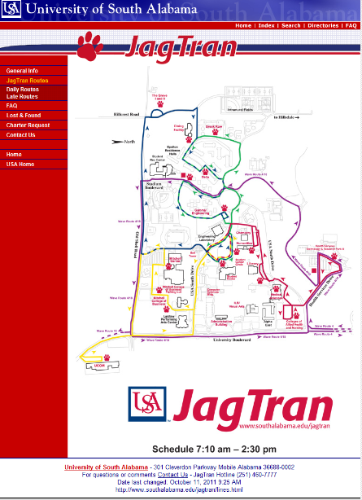

There will be an Android interface that is compliant with Android standards.

Hardware Interfaces
The Network will be used for collecting data from the users and also for updating the system information and tracking journal.

Software Interfaces
A firewall will be used with the server to prevent unauthorized access to the system and it is necessary to set up management operating system.

Communications Interfaces
The Online JagTrack System will be connected to the World Wide Web.

Licensing Requirements
The JagTrack System will be licensed to use Google Maps API.

Legal, Copyright, and Other Notices
The JagTrack System is provided with no warranties, express or implied.

Applicable Standards
The ISO/IEC 6592 guidelines for the documentation of computer based application systems will be followed.

Reference: Online Library System Supplementary Specification

